“WE CANNOT BE MORE CONNECTED TO OTHER PEOPLE THAN WE ARE TO OURSELVES.” -BRENE BROWN
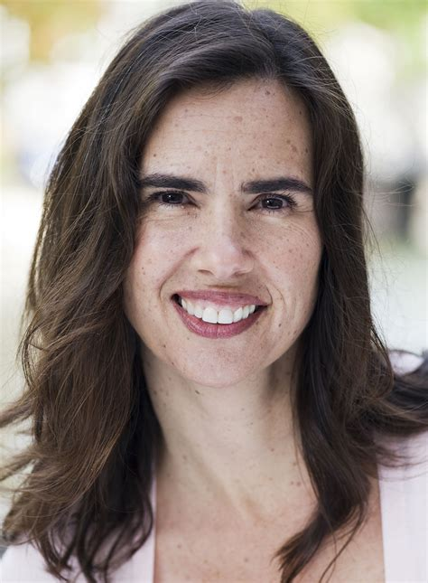

Self-compassion is not just a good idea, it is something one can do…. a powerful way to alleviate suffering that is accessible to anyone at any moment. It can be learned and practiced, and it is not rocket science
--Dr. Kristin Neff, author of The Proven Power of Being Kind To Yourself

Free Info Session On Monday Jan. 20 At 17:30 (ICT, Thailand Time)
(click to register!)

Mindfulness and self-compassion are powerful resources each of us can develop. Mindfulness helps us to be aware and self-compassions empowers us to live and face challenges while we support and motivate ourselves in the same way we would for a good friend.
The MSC course teaches concrete, practical skills for daily life that will help you to respond to difficult moments with kindness and understanding while you also become more able to motivate yourself, stand up for yourself and set limits.
​
This enhanced version of MSC training includes 10 sessions:
- 9 core course sessions X 2.5 hours each (23 hours total) on Mondays at 17:30 ICT (Thailand time) starting Monday Jan., 27 2025, plus
- A 2.5-hour retreat session after the 6th session (see schedule below), plus
- 24 different practice to develop your inner strengths including guided meditations, skills for daily life and additional Fierce Self-Compassion practices!

It’s proven to help! More than 2,000 peer-reviewed studies demonstrate that self-compassion is strongly associated with increased emotional wellbeing and resilience in many ways including less anxiety, depression and stress, better maintenance of healthy habits such as diet and exercise, and more satisfying personal relationships. And it’s easier than you think.

Why Online? Taking the course online empowers you to:
- Participate from the convenience and comfort of your own home, and
- Be deeply engaged with interactive, experiential exercises, while
- Connecting with a diverse community of participants from across Asia-Pacific,
- Learn from the experts: this course is led by Siri Chandler and Ben Weinstein, PhD, two of Asia-Pacific’s most experienced and skilled teachers of secular mindfulness and self-compassion.
Who can participate?: Any adult located in the Asia-Pacific region and Europe are welcome to register! No previous experience with mindfulness or meditation is required.

What to Expect: Course size is limited to 22 participants. Activities include guided meditations, short talks, numerous experiential exercises, small group discussions, and home practices. Please look at MSC as an experiential training and not a class. You’ll be actively engaged in each session. The main goal is for participants to directly experience and learn practices that evoke self-compassion in daily life. Participants should plan to attend every session and practice the skills at least 20-30 minutes per day throughout the program.

Mindful Self-Compassion Course Online Schedule: Jan-April, 2025

Please check the schedule and plan to attend every session- all sessions are on Zoom
ALL TIMES ARE IN THAILAND TIME UTC+7. This is one hour behind Singapore/Hong Kong
Date | Time | What?
Mon., Jan. 20 | 17:30-18:30 | MSC Course Information Session- this free, brief session is a chance to meet the teachers, find out what this is all about and ask questions!
Mon., Jan. 27 | 17:30-20:30  (3 hours) | MSC Session 1: Introducing MSC (3 hours)
Mon., Feb. 3 | 17:30-20:00 | MSC Session 2: Practicing Mindfulness.
Mon., Feb. 10 | 17:30-20:00 | MSC Session 3: Practicing Kindness
Mon., Feb. 17 | 17:30-20:00 | MSC Session 4: Discovering Your Compassionate Voice
Mon., Feb. 24 | 17:30-20:00 | MSC Session 5: Living Fiercely and Deeply
Mon., March 3 | 17:30-20:00 | MSC Session 6: Listening Deeply
Mon., March 10 | 17:30-20:00 | Retreat Session: A wonderful opportunity for deeper, concentrated practice
Mon., March 17 | 17:30-20:00 | MSC Session 7: Strengthening Your Emotional Core
Mon., March 24 | 17:30-20:00 | MSC Session 8: Challenging Relationships & Unmet Needs
Mon., March 31 | 17:30-20:00 | MSC Session 9: Embracing Your Life (final session)
Total = 25 course hours
There will be a 15-minute break in each session.

Completion: Participants who attend at least 90% of the program will receive a certificate of completion, which is the basis for participation in further MSC training.
Participants who are receiving continuing education credit from HKPS must be present at the beginning and end of each session, and complete the weekly reflection 4 times, and the course evaluation.

Registration Fee: USD$400 (about $15/hour)
--Early Bird Discount: USD$300 (register and pay on/before Jan. 3, 2025)
The course is limited to 22 participants. We offer at least 25% of the seats in each course at no charge to local heroes: members of local communities who are actively serving their communities. So, when you pay the registration fee, you’re helping to support this offering!

Please note: Ben and Siri are both MSC Certified teachers and teach the full MSC curriculum and more in this course. Other online MSC courses are abridged and are not the full MSC curriculum.

Steps to Register & Payment:
- Email us to express your interest (or with any questions you have)
- We’ll send you two forms to complete online: an information form and an informed consent. You complete them and send them back to us. We pace our work with self-compassion, so please give us a few days to review and respond.
- We'll send you the link to make payment online. Make your payment and your place is secured! Easy online payment options available.
- Refund policy: If you cancel before/on Jan. 13, you will be refunded your course fee minus a 5.5% processing, gateway, and VAT fee from the online ticketing company, which is non-refundable. If you cancel after Jan. 13 and before Jan. 27, you will be refunded 45% of your course fee. There are no refunds after Jan. 27.

Not Ready To Register But Want More Info First?
Please join us for a free info session on January 20 at 17:30 ICT (Thailand time) by registering here:
https://forms.gle/kuLjquEac5wraihCA

“Self-love is crucial for loving others … What is love? Love is treating your heart with a great deal of tenderness, with understanding, love, and compassion. If you cannot treat your own heart this way, how can you treat your partner with understanding and love?”
— Thich Nhat Hanh

PLEASE SHARE THIS ANNOUNCEMENT WITH ANYONE WHO CAN BENEFIT FROM MORE KINDNESS IN THEIR LIFE!

